**Interview Scheduling Management**

**Checklist for Release Planning**

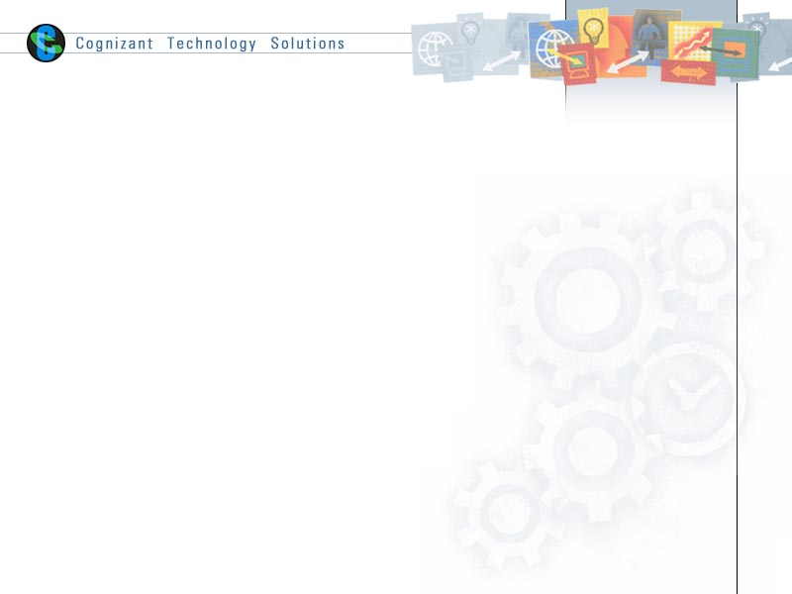

|  |  |
| --- | --- |
| **Prepared By** | |
| **Name** | Rohini Bansal |
| **Role** | Team Member |
| **Signature** |  |
| **Date** |  |

Table of Contents

1.0 Checklist for Release Planning 2

# Checklist for Release Planning

|  |  |  |  |
| --- | --- | --- | --- |
| Sl. No. | Check Points | Status (Yes / No / NA)  (Yes - if the checkpoint is satisfied completely  No - if the checkpoint is satisfied partially, or completely not satisfied  NA - if the checkpoint is not applicable) | Remarks  (If 'No' is selected in 'Status' column, appropriate comments in 'Remarks' column is mandatory.) |
|  | Is the Product Owner available for release planning? | Yes |  |
|  | Are features in product backlog ranked? | Yes |  |
|  | Is there a common understanding among team members to size backlog items? | Yes |  |
|  | Are the participants impacted by release available for meeting? | NA |  |
|  | Has the logistics been planned? | NA |  |
|  | Has multiple/distributed teams been taken into account for meeting? | NO | This is a standalone product & database and not an enterprise product. |
|  | Is the need for experienced facilitator identified? | NA |  |

|  |
| --- |
| Conclusion / Inferences |
|  |